WCF SERVICE:

. In the IService1.cs interface file, under Interface class, we are going to define a sample method named GetData2

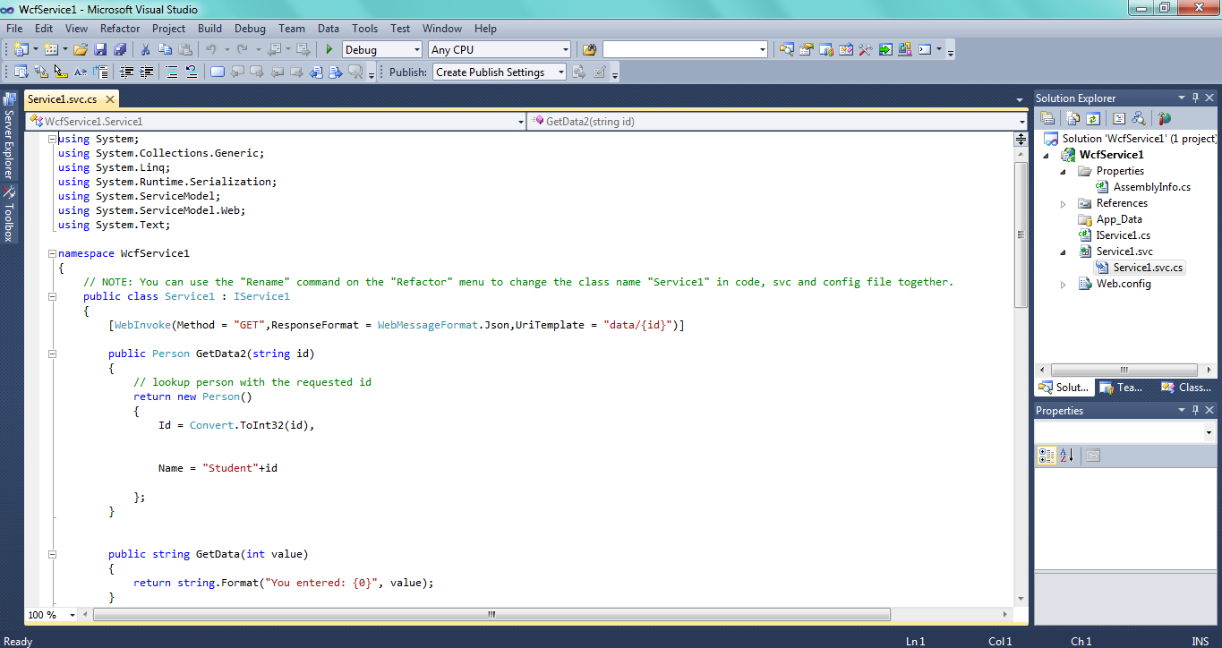

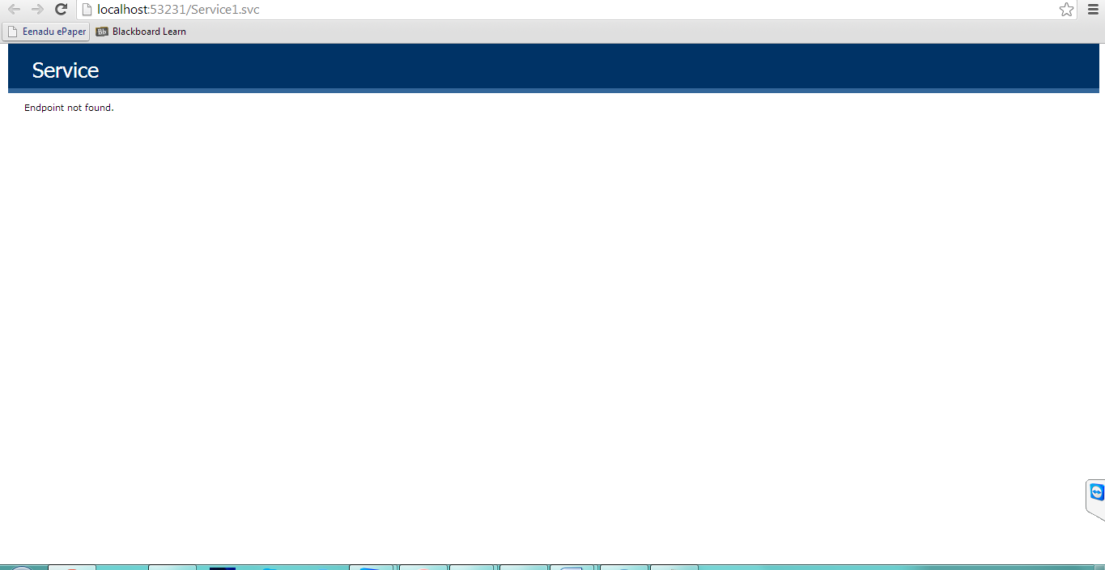

In the Service1.svc.cs file, we will implement the real function under the corresponding interface we get

